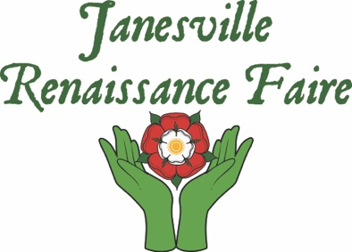

715 N Garfield Ave., Janesville, WI 53545 • Phone: 608-289-0699 • Email: contact@jvlrenfaire.com • Website: http://www.jvlrenfaire.com/

Entertainer Application
Dates: May 18 & 19, 2024
Hours: 10am to 6pm
Location: Traxler Park, 600 N. Main St., Janesville, WI, 53547

Entertainer/Group Name:
Contact Person:
Mailing Address:

Phone:
Cell Phone:
E-Mail:
Website URL:
How long is your set or performance?
Are you a wandering act or a stage show?
Performance Cost/Compensation requested:

Performance Description: Please describe your performance, as well as any special requests needed (space, electricity, overnight parking, etc.) Understand we are a family friendly show and only allow up to PG-13 rated shows.

New performers please provide pictures/demos of your set up and performance via this application to:
Janesville Renaissance Faire
715 N. Garfield Ave.
Janesville, WI 53545

Or e-mail to: contact@jvlrenfaire.com

